BRWIA Female Farmer 2016 Scholarship Fund Application

Supporting Farmers and Strengthening the Local Food System

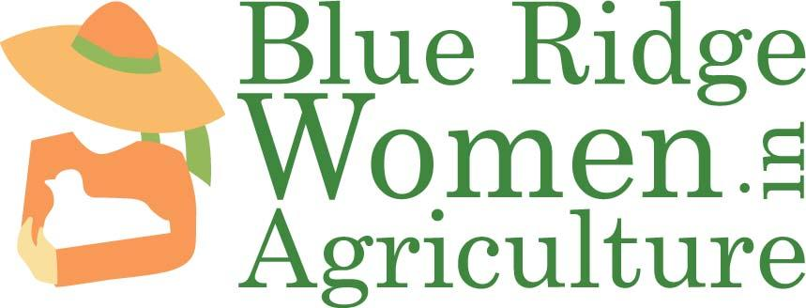

Blue Ridge Women in Agriculture (BRWIA) is happy to announce that we have scholarship funds that will make it possible for a number of female farmers in the High Country to attend an upcoming food and farming related conference, workshop, or training of their choosing. BRWIA is collaborating with the Women’s Fund of the Blue Ridge to make training and professional development opportunities more affordable for female farmers in our service area. Details follow in the sections below and we encourage any female farmer living within the BRWIA service area to apply.

TABLE OF CONTENTS
the Scholarship Application Process 3-4
Scholarship Requirements 3
The Selection process 4
Funding 4
Questions 4
About Blue Ridge women in agriculture (brwia) and women's fund of the blue ridge 4
2016 BRWIA scholarship Proposal 5-8
Personal Information 5
Conference, training, or workshop Description 6
Justification of Attendance 7
Short list of upcoming conferences, trainings, and/or workshops 8

Scholarship Requirements
- Scholarships will only be awarded to female farmers, ranchers, homesteaders and/or processors based in Alleghany, Ashe, Avery, Caldwell, Mitchell, Watauga, Wilkes, or Yancey Counties in North Carolina and Johnson County, Tennessee. Educational institutions are not eligible.
- Scholarships will be given to female farmers, ranchers, homesteaders, and/or processors who plan to attend a non-local (75 miles or more from their residence) food and/or farming related conference, training, or workshop in order to further their professional development.
- BRWIA encourages those applying for our scholarship to first look into the conference, training, or workshop of their choosing and seeing if the host organization offers scholarships of their own.
- Each applicant may submit no more than one proposal per year. Scholarship recipients must wait a minimum of three scholarship cycles before they can re-apply.
- Applicants may apply for up to $250 for cost of registration only. Travel costs may be considered depending on the circumstances. Please indicate in your application if you must have travel expenses covered in order to attend.
- BRWIA scholarship funds will be available to applicants until the money lasts.
- Applicants must submit an application for scholarship funds to BRWIA no later than three weeks before the date of the desired conference, training, or workshop.
  - BRWIA encourages those who know they would like to attend a specific conference, training, or workshop later in the year (summer or fall 2016) to apply now, before funding runs out.
  - BRWIA also encourages applicants to take advantage of cheaper early registration rates, if possible, so that the scholarship fund can fund the most amount of applicants.
- Funds will be reimbursed to the awardees after attending their chosen conference, training, or workshop. BRWIA will consider making exceptions and giving funds up front depending on the circumstances of the applicant.
- Scholarship awardees must inform BRWIA as soon as possible to any changes in registration or attendance to the conference, training, or workshop.
- With the support and guidance of BRWIA, scholarship awardees are responsible for writing a short essay related to their educational experience at the conference, training, or workshop they attended. This essay will be shared in the BRWIA newsletter and website to demonstrate how attending the conference, training, or workshop benefitted the attendee.

Proposals may be sent electronically OR in hard copy.
Email proposals to sarene@brwia.org
Mail hard copy proposals to:
BRWIA
P.O. BOX 67
Boone, NC 28607
Proposals must be RECEIVED no later than three weeks before the date of the conference, training, and/or workshop you plan to attend. The sooner the better!

The Selection Process
All funding by the Blue Ridge Women in Agriculture Scholarship Fund is awarded competitively, and we anticipate that we will receive more proposals than can receive funding. A Scholarship Review Committee, made up BRWIA staff, will evaluate all scholarship proposals received and decide which proposals will be funded. This is a rolling acceptance situation, so BRWIA would advise applying for the scholarship as soon as you know of an event you want to attend because funding will not last the entire year.
Funding
If you are awarded a Blue Ridge Women in Agriculture Scholarship, you will be paid by reimbursement for cost of registration. As mentioned above, exceptions to these reimbursement policies can be modified but the awardee must communicate with BRWIA in a timely manner to do so.

Questions

If you have questions about your scholarship proposal, please don’t hesitate to contact our Executive Director by writing to Carol Coulter at carol@brwia.org or by calling 828-386-1537.

About Blue Ridge Women in Agriculture (BRWIA)
Blue Ridge Women in Agriculture (BRWIA) is dedicated to strengthening the High Country's local food system by supporting women and their families with resources, education, and skills related to sustainable food and agriculture. For more information about our programs, visit www.brwia.org.
About Women’s Fund of the Blue Ridge
Women’s Fund of the Blue Ridge is on a mission to create positive change and economic justice for women and girls in the counties they serve. Through funding to local nonprofit agencies, they aim to be a philanthropic catalyst for all women and girls to have access to the resources they need as they strive to become empowered and reach their full potential. They are women helping women to build bright futures. Visit www.womensfundoftheblueridge.org to find out more!
This year, Women’s Fund of the Blue Ridge was able to grant Blue Ridge Women in Agriculture with enough money to provide two small farmer grants to females in their service area through the Mary Boyer Sustainable Food and Agriculture Grant AND have some funds left over to provide the opportunity for small-scale female farmers to attend local conferences, trainings, and/or workshops through a scholarship fund.

Personal Information

Name of farmer, rancher, homesteader and/or processor and name of farm (if applicable):

Full address:

County:

Telephone:

Email:

Please tell us about you and your farm, ranch operation, homestead, or company in less than 100 words:

Conference, Training, or Workshop Description

Name of conference, training, or workshop:

Date, location, and registration cost of conference, training, or workshop:

Have you attended this conference, training, or workshop in the past?

In less than 300 words, please describe the conference, training, and/or workshop you seek funding for:

Justification of Attendance
In less than 300 words, please address the following questions:
- How will this conference, training, and/or workshop enhance your professional development?
- What do you plan to do with the knowledge you gain from this conference, training, and/or workshop?

Short List of Upcoming Conferences, Trainings, and Workshops
This list if very brief and is intended to show only a small amount of well-known upcoming events. Please do not limit yourself to these events and research other conferences, trainings, and workshops – even if they are out of state.
- Browse events offered by the Biodynamic Association here: https://www.biodynamics.com/calendar
- Wild Herb Weekend – July 22-24, 2016. http://www.ncherbassociation.org/#!wild-herb-weekend/ca3p
- Growing Minds Southeast Farm to School Conference – September 23-24. http://growing-minds.org/farm-to-school-conference/
- Women Working in the Meat Business Conference - October 2-4, 2016 - http://www.carolinameatconference.com/women
- Carolina Farm Stewardship Association (CFSA) Conference – November 4-6, 2016. https://www.carolinafarmstewards.org/sac/
- Southern Sustainable Agriculture Working Group (SAWG) events page. http://www.ssawg.org/events

